Question 1:

|  |  |
| --- | --- |
| **User Action** | **System Response** |
| User types in PIN into main screen | System checks validity of PIN and presents options to user on another screen |
| User chooses to enter into withdrawing- screen | System presents a screen to user for typing in amount of withdrawing |
| User types in the amount of withdrawing | System checks balance of account and take cash out |

Question 2:

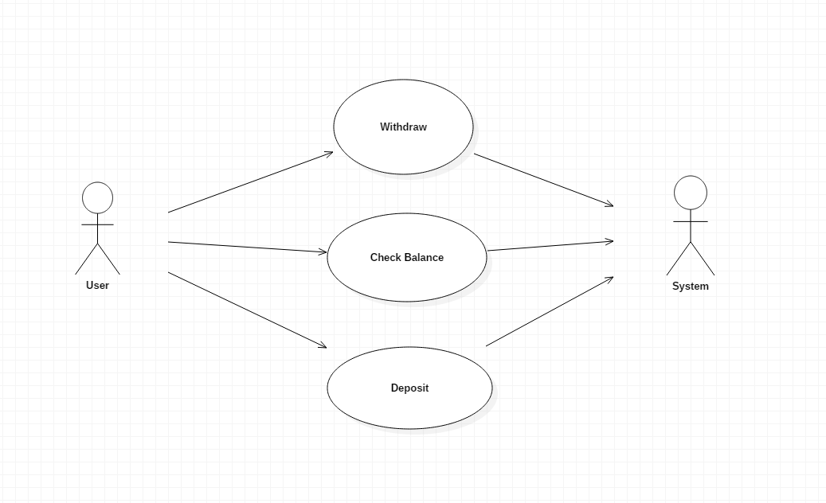

Question 3:

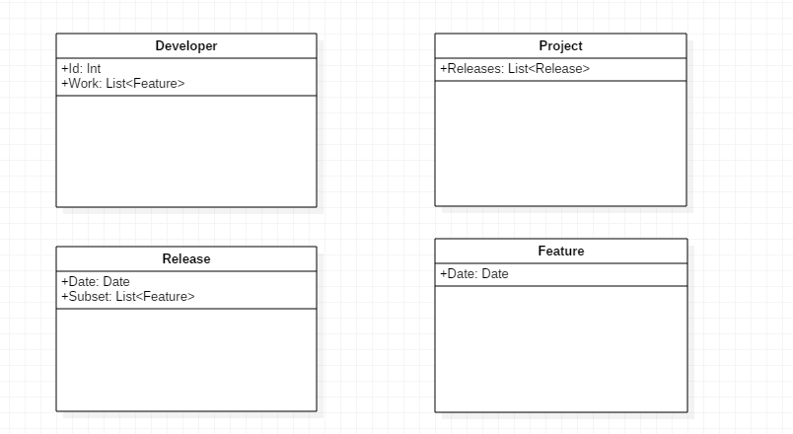

Question 4:

